**Meeting Preparation**

Created Date: 07/10/2016

Creator: QuyetNH

1. **ERD:**

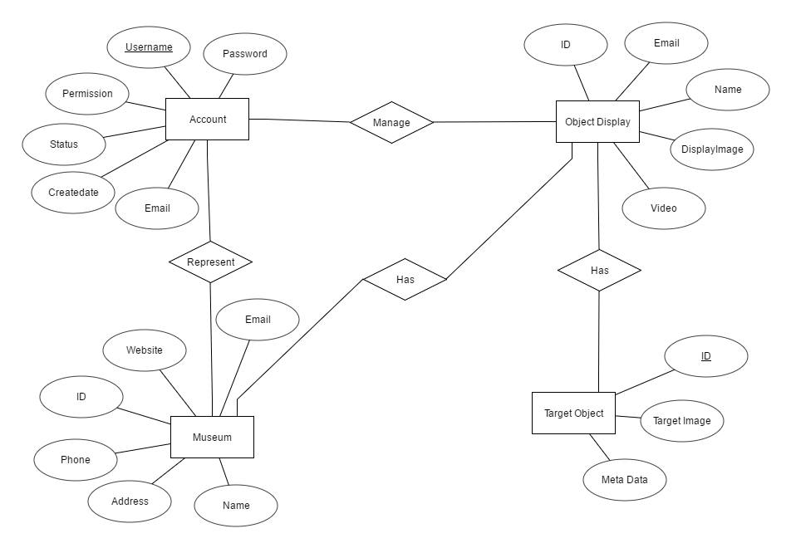

1. **Naming document rules:**

Form: What_Version_Description_Owner

What: MeetingMinute, DBDesign, UCDiagram, …

Version:

Version naming: vxx

v: prefix

xx: number of version

Ex: v01, v02, v99…

Description:

Form ExtraInformation_Date_Type

Date format: yyyymmdd

Type: Draft, Working, Final

Description can be delimited by underscore: "_"

ex: MeetingMinute_Num1_20161002_Final

Owner: ToanMQ, GiangPV, QuyetNH, HuyKH, TungNX

Do not use space and other character such as: ! # $ % & ' @ ^ ` ~ + , . ; =

Use Capital Character as word delimiter.

Fist Letter must be uppercase.

Example:

MeetingMinute_Num1_20161002

UCDiagram_v01_20161002_Draft_ToanMQ

1. **Statuses diagram of Objects’ information:**

Data commit

Data is not verified

Update data request accepted Data is verified

1. **Checking list to verify team document:**

